Banking System Assignment

Documentation

Tumisang Tlou

Cse24-162

System Documentation

**1. Requirements Elicitation**

1. **Functional Requirements**
2. **Non-Functional Requirements**:

1. **Structural UML Modelling**

**2.1. System Use Case Diagram**

**2.2. Class diagram**

**3. Behavioural UML Modelling)**

**3.1. Login and Deposit** **Sequence Diagrams**

**3.2. State Diagram**

**Meeting record appendix**

1. Requirements Elicitation
   1. Functional requirements

These requirements detail what the system must do to meet user needs

#1 customer and employee authentication

*login for customer* -the system must allow a customer to securely log in using a unique identifier and password

*Login for employee* - the system must allow a bank employee to securely log in with specific credentials to access the administrative functions.

#2 customer management

*create customer* -Employee to create a new customer account capturing essential details such as name and address the system is also be able to differentiate between an individual customer and company customer and store their specific details.

*View and update customer details* - the system must allow employees to view and modify customer information.

#3 account management and transactions

Create account- a system must allow an employee to create new accounts. A single customer can have multiple accounts including a savings investment or check account at most one of each

*Make a deposit* -the system must allow customers to deposit funds into any of the accounts

*Make a withdrawal -* the system must allow customers to withdraw funds from their investment and check accounts it must prevent withdrawals from the savings account

*View account balance and history -* the system must allow a customer to view the current balance and the history of all transactions for each of the accounts

#4 Interest Payment

*Pay interest -* The system must automatically calculate and pay a monthly interest to savings account and investment account

*Savings account*- the system must calculate and pay a monthly interest of 0.075 on the balance to company customers and a monthly interest of 0.025 on the balance to individual customers.

*Investment account-* the system must calculate and pay a monthly interest of 5% on the balance.

* 1. Non-Functional requirements

These requirements describe the quality attributes of the system by addressing how it performs rather than what it does.

*Security-* the system must ensure that all customer and bank data are securely stored and protected from unauthorized access. User authentication must be secure to prevent unauthorized entry. To make it secure the password must be a minimum of eight characters comprised of numbers and alphabets.

*Usability*- the user interface should be intuitive and easy for both customers and employees to navigate.

*Scalability*- The system's architecture should be designed to handle a small to medium number of customers and transactions

1. Structural UML Modelling

2.1 System Use Case Diagrams

[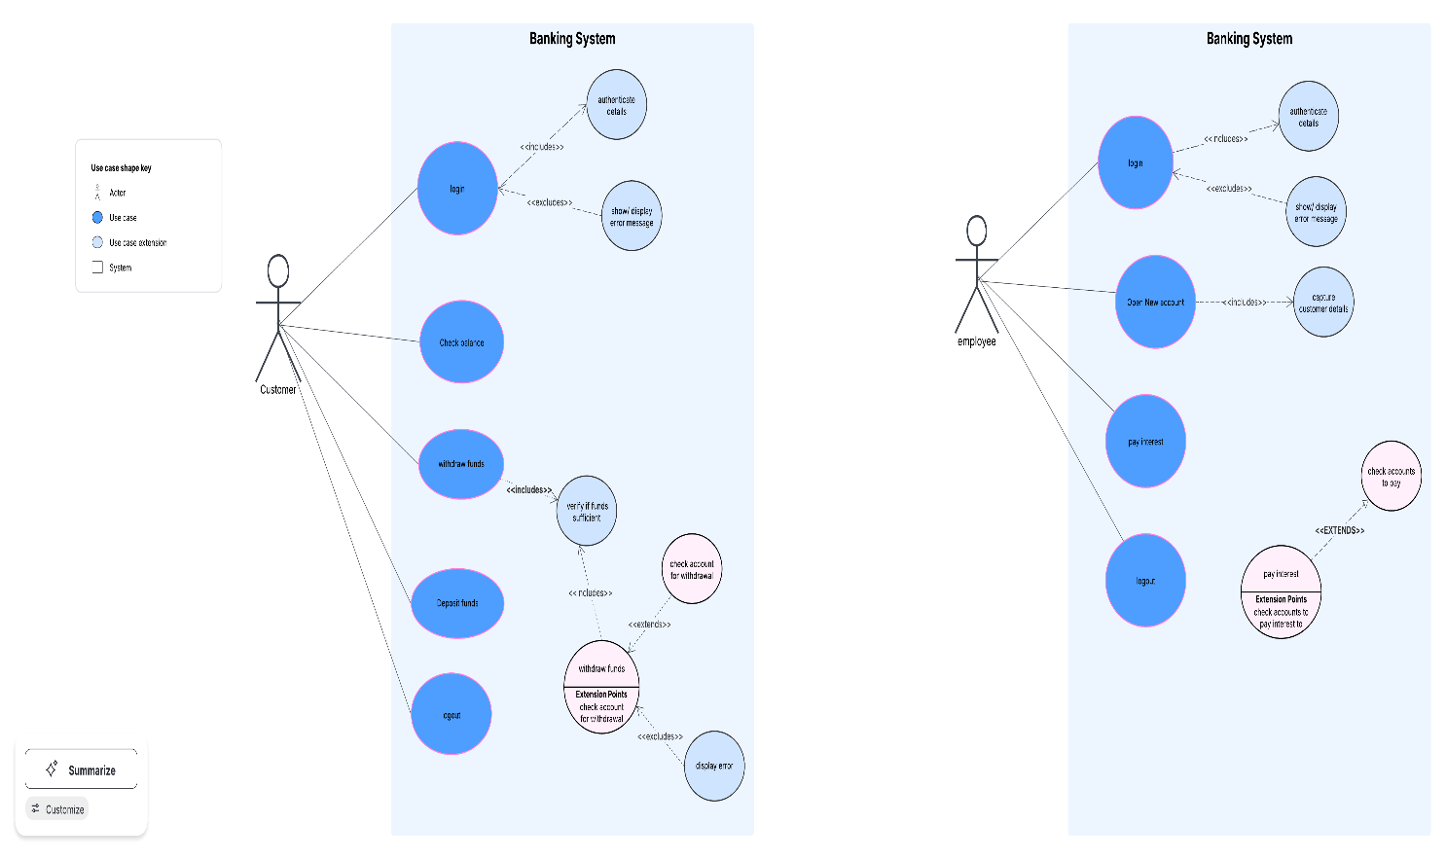](https://lucid.app/lucidchart/2b9df653-4990-4578-ac3d-b0cb29eb01f9/edit?crop=content&page=0&signature=9945926b8f594876b56801639ccb13d89fd8e9831e7197cc1376bde4cadd81b3)

2.2 Class Diagram

[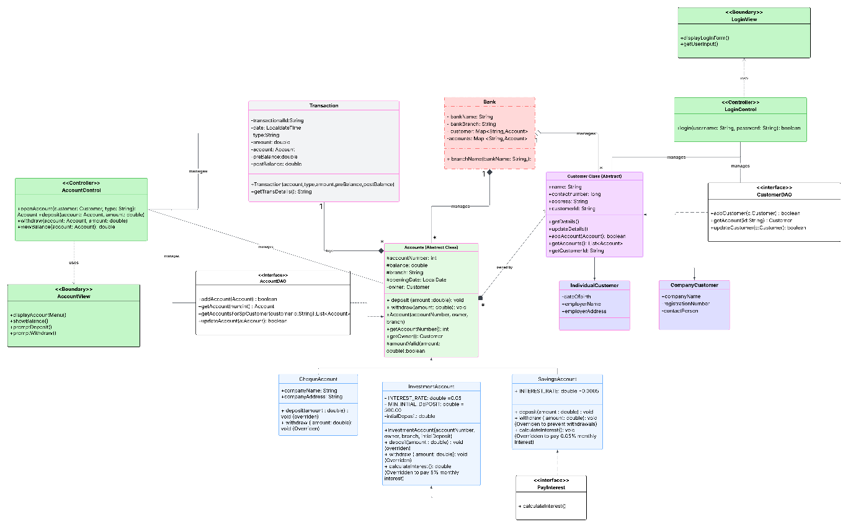](https://lucid.app/lucidchart/2c7294fd-33bb-43dc-a15f-673911e86d76/edit?crop=content&page=0&signature=776a9e4f0273184ab88715a09bed6278f3fe0948ed80d091f415560b1a801159)

1. Behavioural UML Modelling

3.1 Sequence Diagrams

[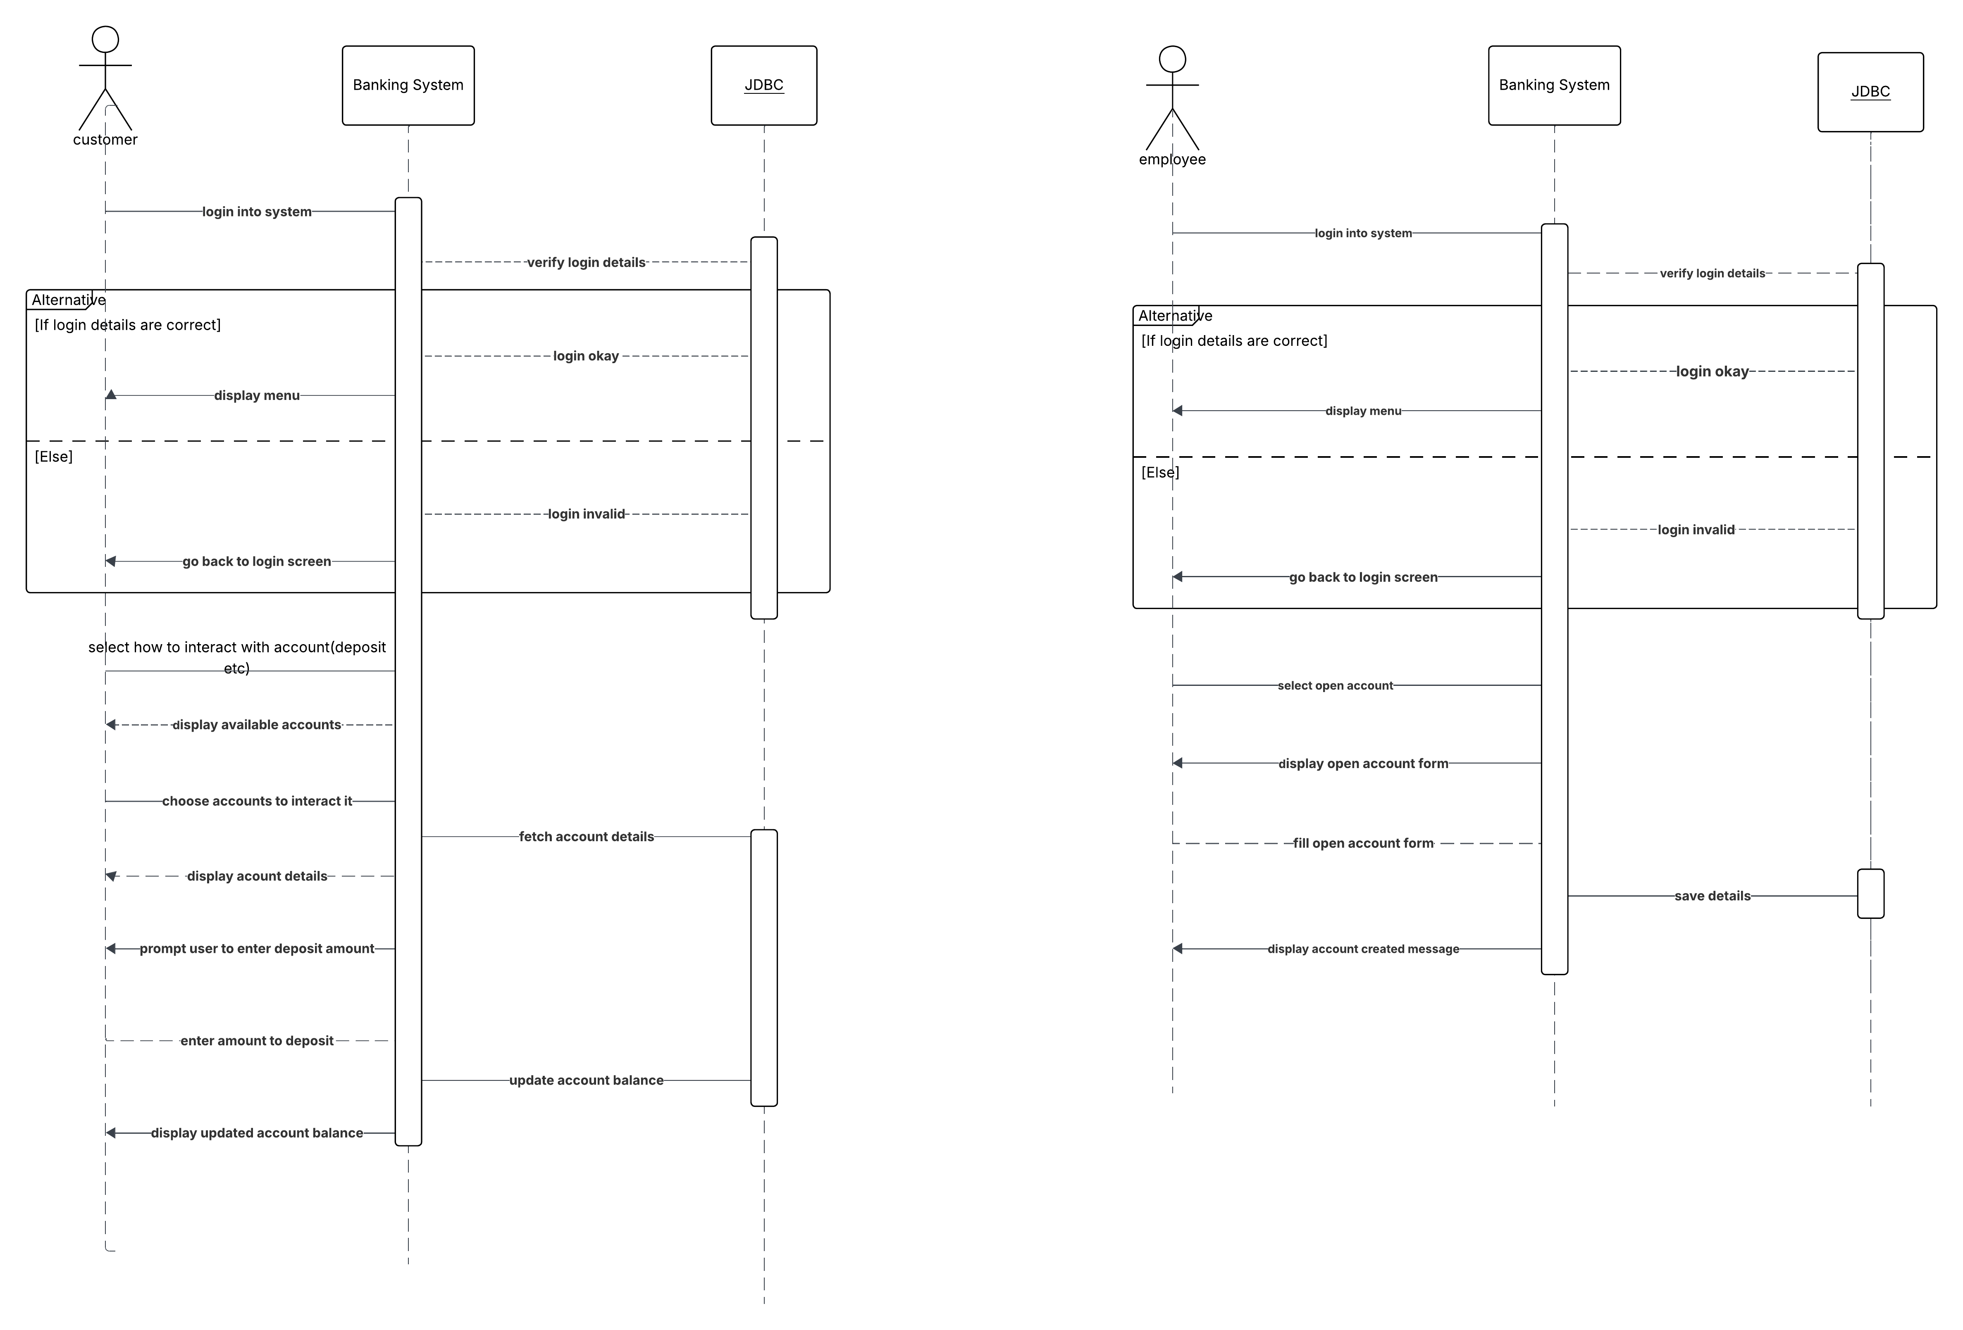](https://lucid.app/lucidchart/aa744714-ac35-4d4e-9d78-737ee02a99f4/edit?crop=content&page=0&signature=c181a465e60a2503a4c93f7ef2164f210b50d0352c4f0cdb293788e0fb6cf81a)

3.2 State Diagram

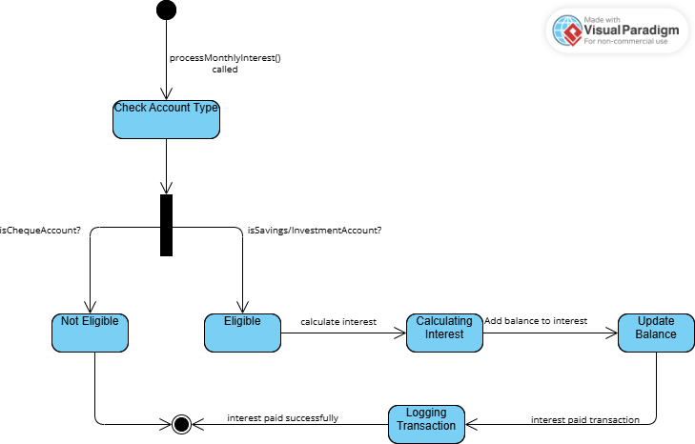

Appendix: Meeting Record

Meeting Title: Requirements Elicitation Interview

Date: 18/09/2025

Time: 1030-1220

Location: Virtual Meeting

Attendees:

Tumisang Tlou, Software Developer (Interviewer)

Mr. Moeng, Mr. Baseki, Banking System Client (Interviewee)

Agenda Items:

* 1. Introduction and project overview
  2. Discussion of core functional requirements
  3. Discussion of non-functional requirements

Discussion and key Outcomes

Functional Requirements

User authentication - The client confirmed the need for the same login portal for customers and employees but leading to two different interfaces with employees having administrative privileges. It was also clarified that a password for the login must have a minimum of 8 characters comprising of both numbers and alphabets.

Customer creation- it was clarified that an employee must be the only one to create a new customer and there will be two types of customers individual customer and company customer each with different data fields

Account management -The client check account verified the need for savings account check account and investment account

Interest payment - the client confirmed specific interest rates to be applied 0.05% as a base for the savings account and 5% for the investment account. It was then decided that the individual and company savings account would have different interest bearing rates, 0.025 and 0.075 respectively.

Non-Functional Requirements

Security - the client emphasized that data security is crucial especially for personal and financial data the system must use secure authentication protocol have encryption

Graphical interface - the client emphasized that the system must have a cohesive interface for both the customer and employee with minor differences in functionality for each side.